**TUGAS PERTEMUAN 1**

**REACT JS**

Nama : Maulana Ardhiansyah Prasetyo

Role : Full Stack Web Developer Group 1

Instansi : Universitas Negeri Surabaya

Link Github Reporitory: <https://github.com/22-Maulana/Tugas-Studpen-General>

1. 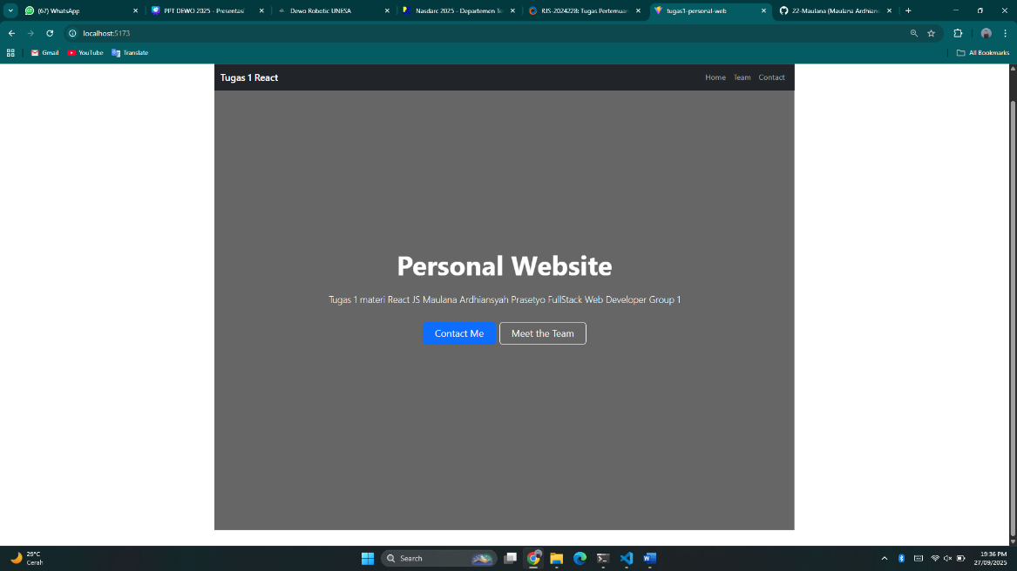**Screenshoot Homapage**
2. 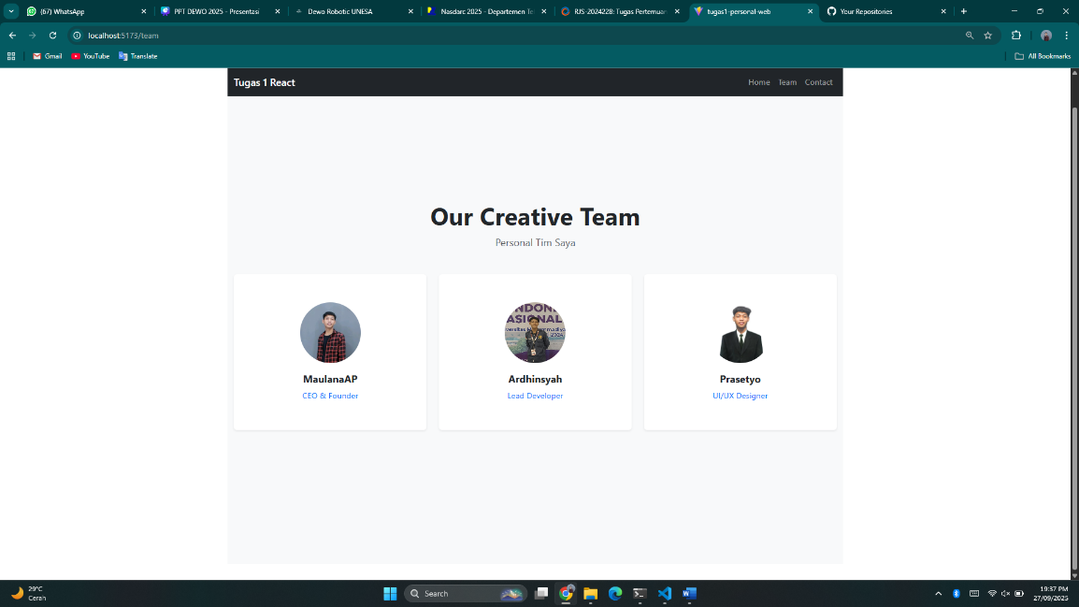**Screenshoot Team**
3. **Screenshoot Contact**

